| **Test Name** | | | Facebook Login - Not logged in to Facebook on the users device | | | |
| --- | --- | --- | --- | --- | --- | --- |
| **Use Case Tested:** | | | Facebook Login | | | |
| **Test Description:** | | | This will test that a person can login using Facebook when they are not logged into their Facebook account | | | |
| **Pre-conditions** | | | Game must be launched | | | |
| **Post-conditions** | | | That a person will login using Facebook | | | |
| **Notes:** | |  | | | | |
| **Result (Pass/Fail/Warning/Incomplete)** | | **Pass** | | | | |
|  | **TEST STEP** | | | **EXPECTED TEST RESULTS** | P | F |
|  | Press Facebook login button | | | That the button will open the Facebook login dialogue | P |  |
|  | The user will input the Facebook user information | | | That they can input the required information | P |  |
|  | Press Login | | | That the user will see the Facebook dialogue telling them what details will be shared | P |  |
|  | The user will need to agree by pressing the button displayed. | | | On pressing agree, the user will be logged in, taken to the main menu and a welcome message displayed | P |  |

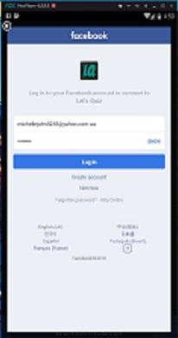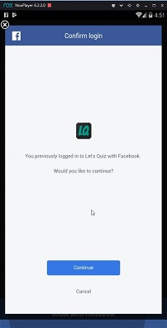

Facebook dialogue login from login button Facebook acceptance dialogue Welcome message

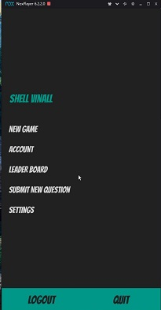

Main menu once logged in

| **Test Name** | | | Facebook Login-Logged in to Facebook on the users device | | | |
| --- | --- | --- | --- | --- | --- | --- |
| **Use Case Tested:** | | | Facebook Login | | | |
| **Test Description:** | | | This will test that a person can login using Facebook when they are logged into their Facebook account | | | |
| **Pre-conditions** | | | Game must be launched | | | |
| **Post-conditions** | | | That a person will login using Facebook | | | |
| **Notes:** | |  | | | | |
| **Result (Pass/Fail/Warning/Incomplete)** | | **Pass** | | | | |
|  | **TEST STEP** | | | **EXPECTED TEST RESULTS** | P | F |
| 1. | Press Facebook login button | | | That the user will see the Facebook dialogue telling them You have previously logged in to Let’s Quiz with Facebook. Do you wish to continue? | p |  |
| 2. | The user will need to agree to continue by pressing the button displayed. | | | On pressing agree, the user will be logged in, taken to the main menu and a welcome message displayed | P |  |



Facebook acceptance dialogue Welcome message Main menu once logged in



| **Test Name** | | | Facebook Login-Data base | | | |
| --- | --- | --- | --- | --- | --- | --- |
| **Use Case Tested:** | | | Facebook Login | | | |
| **Test Description:** | | | This will test that database stores an account for Facebook users | | | |
| **Pre-conditions** | | | Game must be launched | | | |
| **Post-conditions** | | | That the details will be stored in database | | | |
| **Notes:** | |  | | | | |
| **Result (Pass/Fail/Warning/Incomplete)** | | **Pass** | | | | |
|  | **TEST STEP** | | | **EXPECTED TEST RESULTS** | P | F |
| 1. | Press Facebook login button | | | That their details will be stored in the database | P |  |

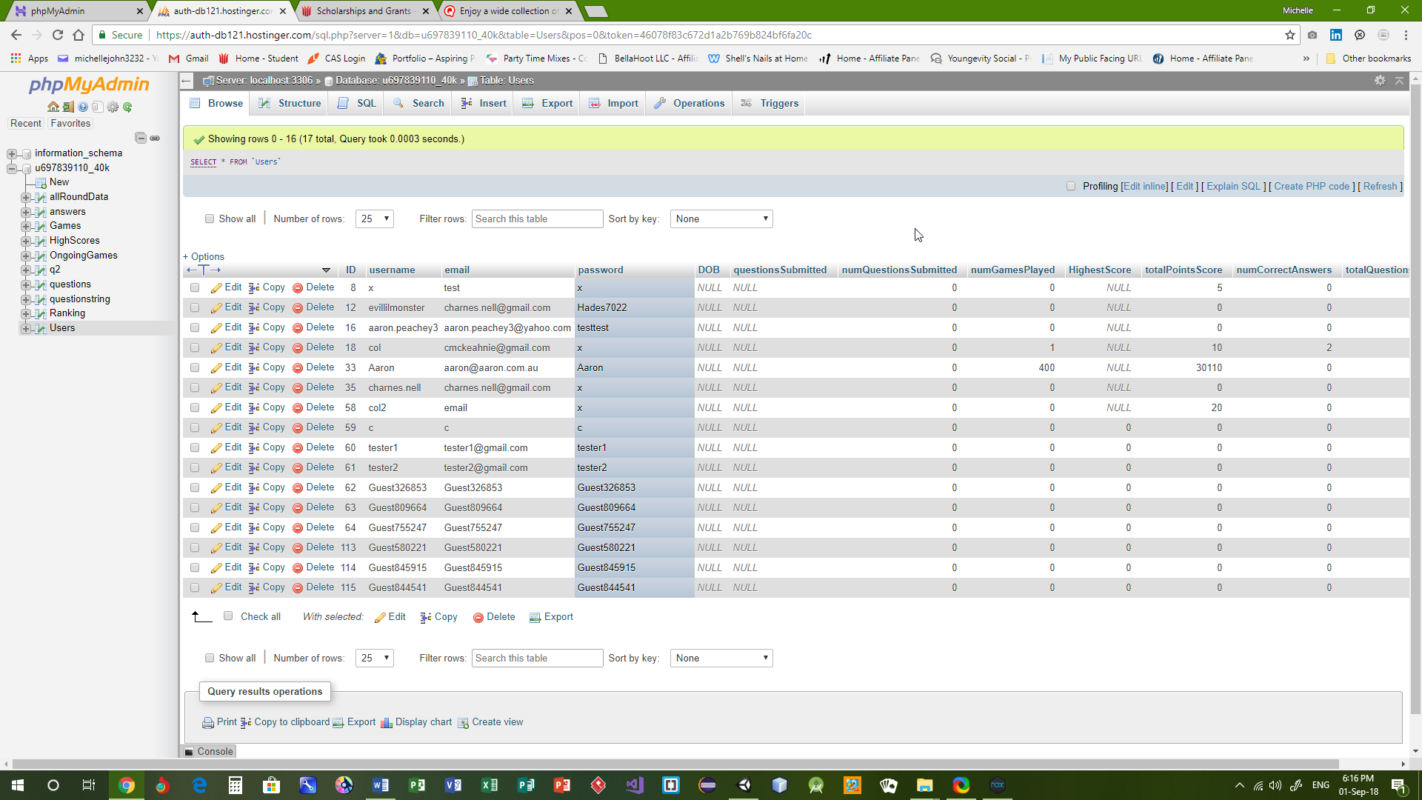

Database prior to Facebook login Last entry 115

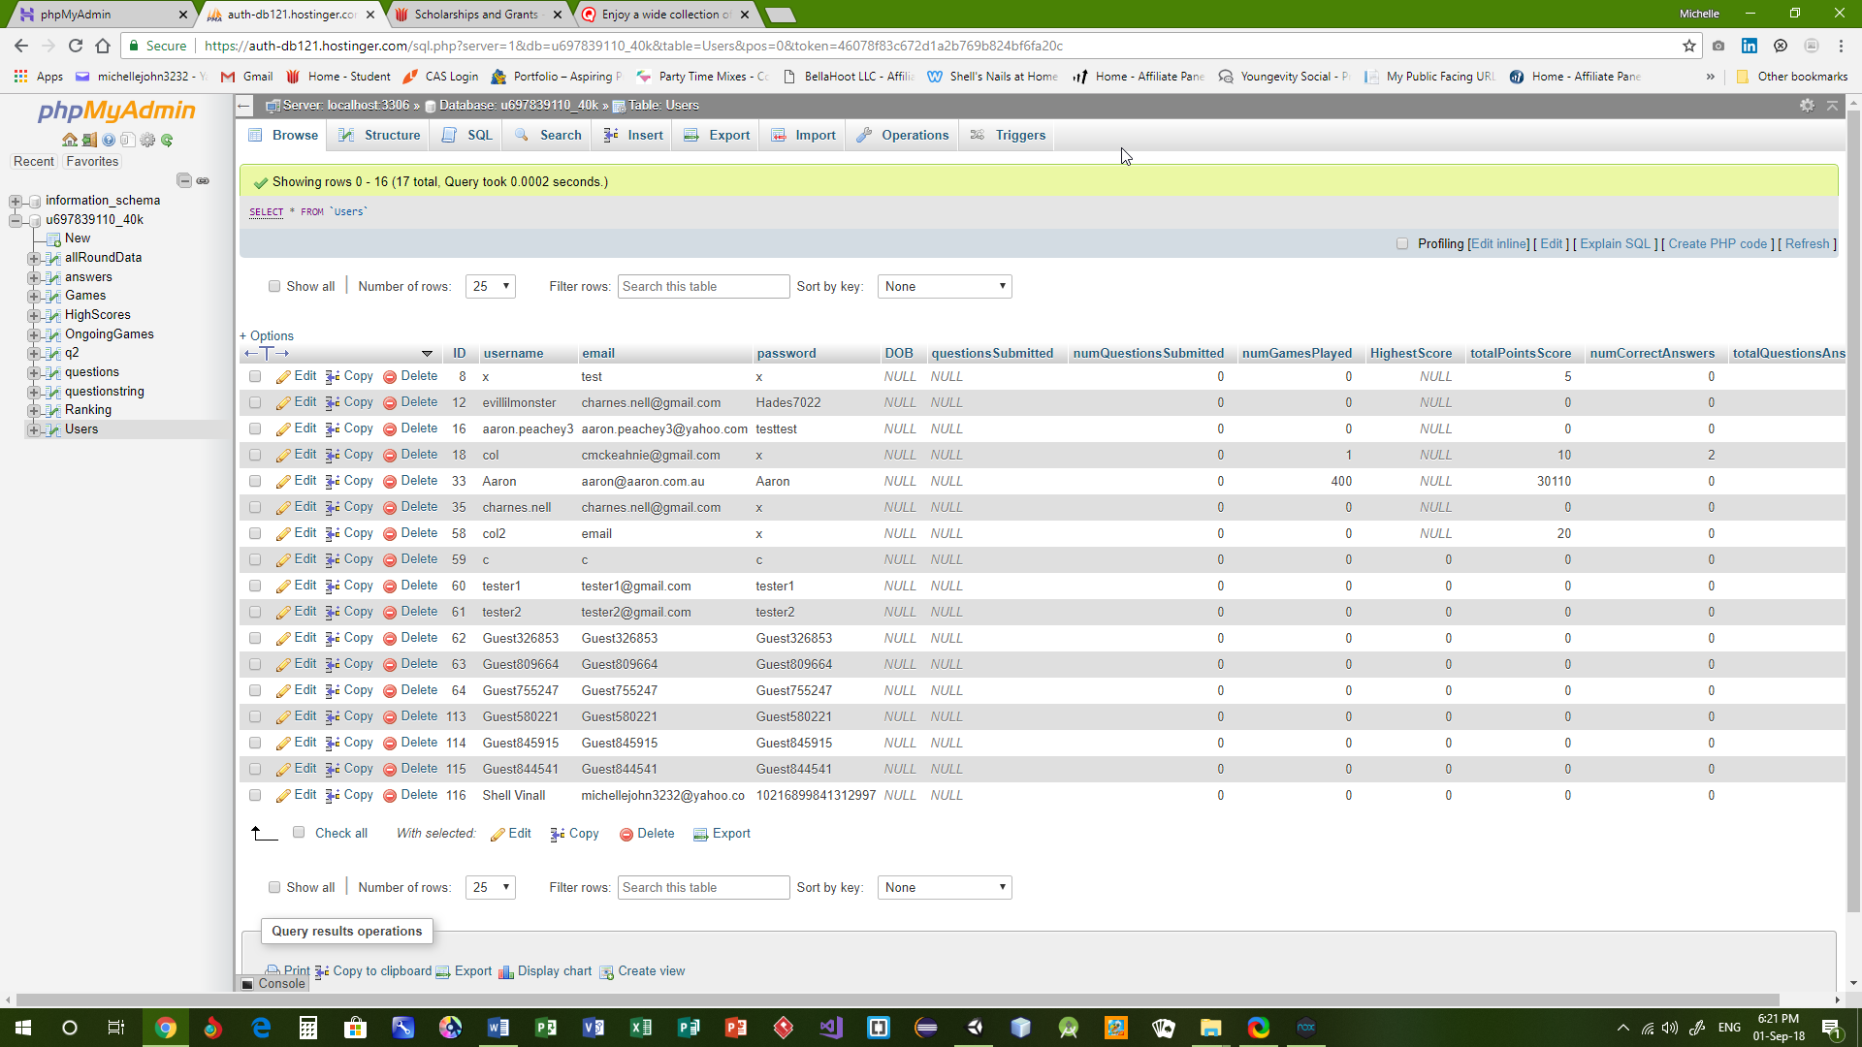

Database after Facebook login Row for user 116

| **Test Name** | | Facebook Login-Share Game | | | |
| --- | --- | --- | --- | --- | --- |
| **Use Case Tested:** | | Facebook Login | | | |
| **Test Description:** | | This will test that a person is able to share the game on their Facebook profile | | | |
| **Pre-conditions** | | Results page must be open | | | |
| **Post-conditions** | | That a person will be able to share to Facebook | | | |
| **Notes:** | |  | | | |
| **Result (Pass/Fail/Warning/Incomplete)** | | **Pass** | | | |
|  | **TEST STEP** | | **EXPECTED TEST RESULTS** | P | F |
| 1. | Press Facebook share button | | That the game will be shared on their Facebook profile | P |  |

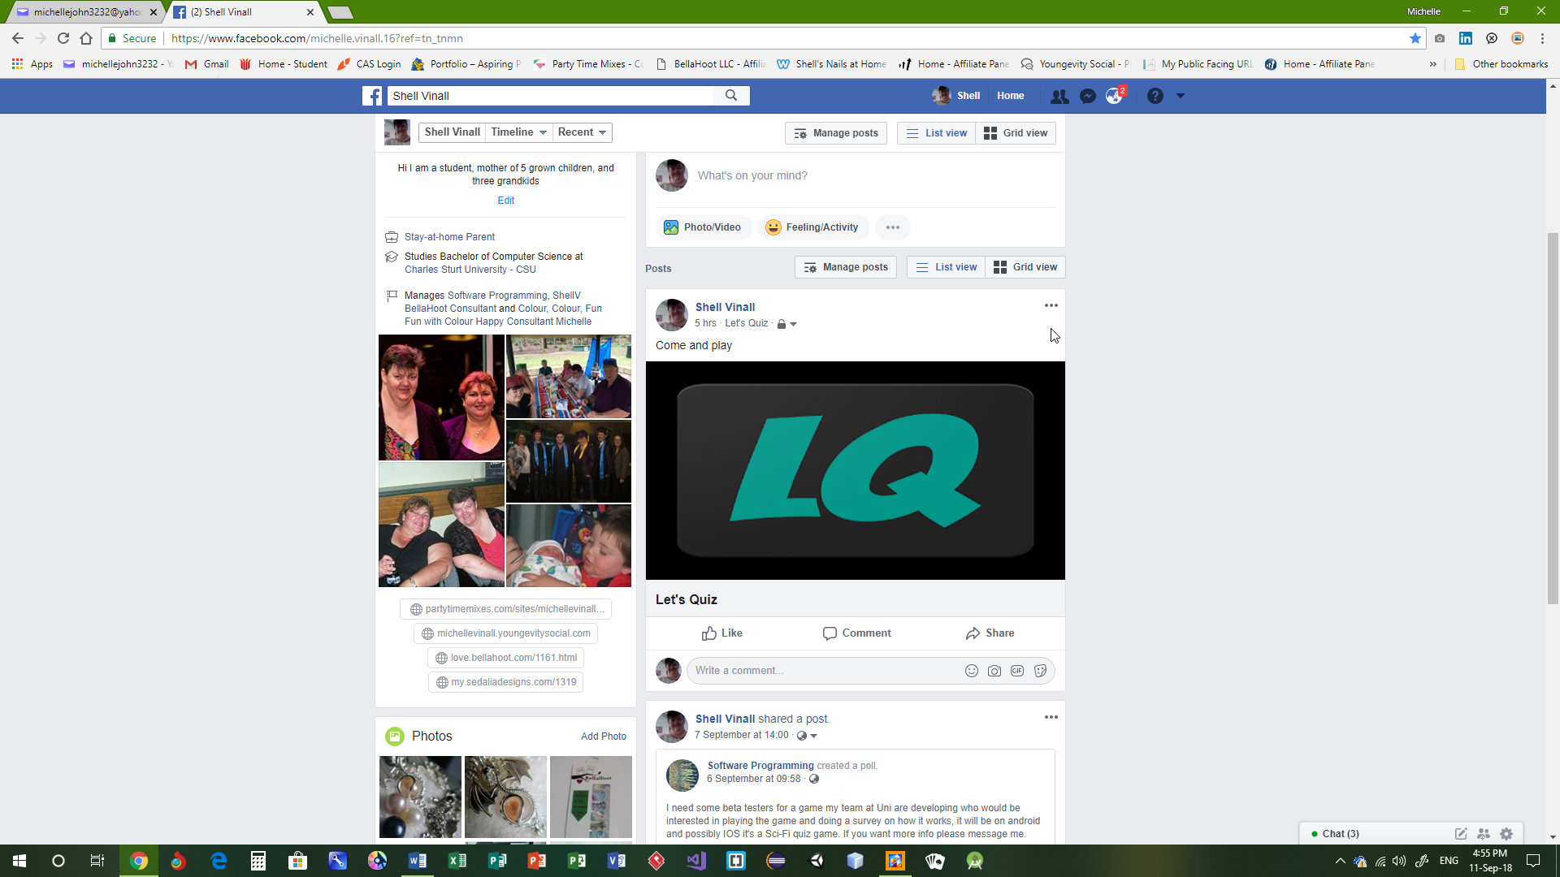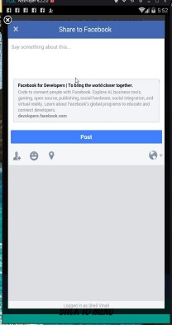

Share Dialogue Post on my Facebook page

| **Test Name** | | Facebook Login-Share Game Button | | | |
| --- | --- | --- | --- | --- | --- |
| **Use Case Tested:** | | Facebook Login | | | |
| **Test Description:** | | This will test to see that share button is not viewable when a person is not logged in via facebook | | | |
| **Pre-conditions** | | Results page must be open | | | |
| **Post-conditions** | | That a person will be able to share to Facebook | | | |
| **Notes:** | |  | | | |
| **Result (Pass/Fail/Warning/Incomplete)** | | **Pass** | | | |
|  | **TEST STEP** | | **EXPECTED TEST RESULTS** | P | F |
| 1. | Play game to results page | | That if a person is not logged in with Facebook the share button will be invisible | P |  |



Logged in as roundtwotests Logged in with Facebook   
no share button share button visible